Poignant Book by A Mother Who Lost Her Teen Daughter Shares Touching & Insightful Guidance on Grieving

“Kim my friend. A woman full of strength and grace. In spite of a heart-crushing tragedy, Kim has braved her way toward the Light. She didn’t sprint past her pain, but Kim has waded into the pool of her reality and has come forth offering us hope.” -Patsy Clairmont, Author of You Are More Then You Know

“What’s truly amazing is that now, 20 years later, I wasn’t reading about a tragedy, or even a family’s hope in the wake of tragedy. I was reading about a stunning and complete victory over tragedy.” --Tom Mercer, Senior Pastor, High Desert Church
Larry and Kim were two divorced, single parents of young girls when they met and fell in love. The girls were raised as true sisters. Later, Larry and Kim would have a daughter together. They also adopted several children. But when tragedy struck right after Christmas in 1998, a loss so deep and unimaginable, Kim had to find a way to grieve and still live life fully. The devastating loss of her 17-year-old daughter, Nicole, left a void in her world.

Any loss of life is a burden to survivors, but to lose one’s child is often thought to be the greatest loss of all. But Kim, after many tears shed and wounds salted, is giving something back to the millions of people each year who lose a loved one – and to the tens of millions who seek to comfort those who suffer a loss. Her new book Victorious Heart: Finding Hope and Healing after a Devastating Loss (Morgan James Publishers, Trade paper, $16.95, 160 pages, ISBN: 978-1- 64279-190-1) honors young Nicole’s life and provides a cathartic process to Kim while sharing useful advice, guidance, and support for those in the throes of grieving.

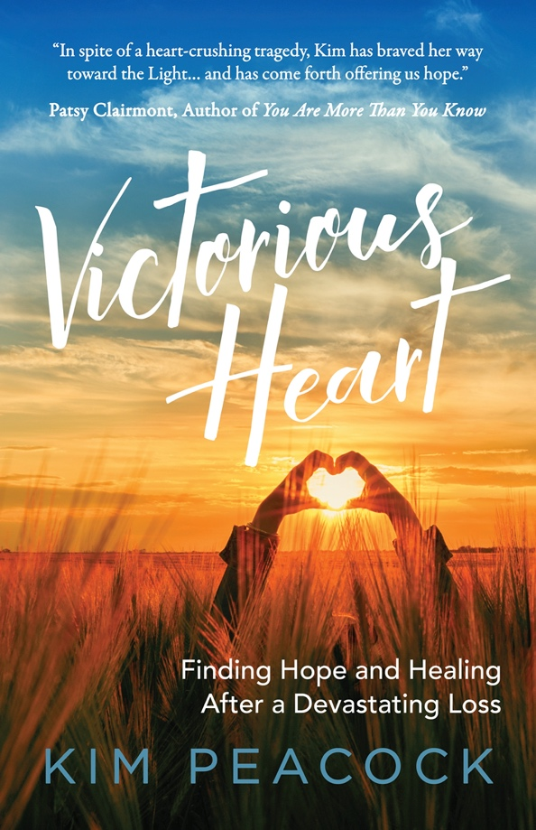

Kim’s touching story and poignant book shows us:
- Grief is a personal and individual journey
- Honor our loved one in death by embracing life
- Sorrow and joy can co-exist and are a part of the healing process
- How to handle the holidays when mourning the loss of a loved one
- How a family learns to live without one of its members and discover a new normal
- How to convert the crushing pain of sorrow to help others.
- What to do or say- and not do or say-while comforting those who are grieving

Not only did Kim Peacock suffer the loss of her daughter Nicole, she witnessed it, a horrific ATV accident while on a family vacation. Ironically, she is no stranger to cemeteries. Her dad was the grounds superintendent for a local cemetery, and she and her husband own a cemetery service construction company. They worked at the very cemetery Nicole was buried.

“Even though you never ‘get over’ the loss of a loved one,” says Kim,” you are honoring them by living well and not forgetting them. You can live victoriously in the midst of your grief. Victorious Heart was written to help those in the valley of sorrow to know that they are not alone, and they will make it through the heartbreak of losing a loved one.”

Kim’s book is a beautiful story of hope and healing. It helps provide answers to questions about surviving a deep pain, how one finds joy again, and how to navigate challenging moments months and years later.

Losing a loved one is a devastating event that can leave people in a broken place, with no way out in sight. This grief is natural, and cannot simply be ‘cured,’ but Kim uses her experience to show people the best ways to handle it. Victorious Heart shows sufferers that even during these dark times, they always have hope.

“Words can’t bleed.
“They can’t rapture.
“They can’t repeatedly drown in agony.
“So, it will be hard for me to convey the depth of sorrow a parent wades in when their child dies. I can try. You can imagine. Yet whatever I say, and whatever you think, it’s more … so much more. …Hope is not fragile; just hard to find when the lights go out.”

- Excerpt from Victorious Heart
Kim Peacock is the author of Victorious Heart, which details her handling of grief over the loss of her 17-year-old daughter. It also provides insightful advice for those seeking to support and help those who grieve. She has raised six children, residing with her second husband in a log house in Mt. Juliet, Tennessee. Several years ago, they relocated from the desert of Southern California. She is the CFO of Peacock Engineering, a cemetery construction company that specializes in cemetery improvement and expansion. Through her blog, wildvictoriousheart.com, her book and speaking Kim acts as a grief mentor to others in need. Her blended family includes a stepdaughter, a daughter with her current husband, and three adopted children. She also has several grandchildren.

Contact Information:
Kim Peacock victoriousheart99@yahoo.com
P.O. Box 823, Mount Juliet, TN 37122
(760) 250-9724
